### Statement of Understanding for ACM In-Cooperation Conferences

The enclosed In-Cooperation Technical Meeting Request Form has been prepared to the best of my ability.

*It is complete and accurate. If this conference is approved for ACM Cooperation, it is agreed that:*

ACM members will be permitted the same fees for registration, proceedings etc. as members of the sponsoring organization(s).

The conference will provide one complimentary copy of the Conference Proceedings to ACM for archival purposes. That copy should be sent to: **ACM SIG Services Department, 2 Penn Plaza, Suite 701, New York, New York 10121.**

All publicity relating to this conference is to state that the meeting is “In-Cooperation with ACM.” The ACM logo with a registered trademark symbol must be displayed and may be obtained from ACM Headquarters SIG Services Department.

I am informed of the ACM policy on free circulation of scientists as it applies to the ACM Resolution on Sponsorship of International Conferences of 25 May 1975 and of the spirit and intent of the relevant Resolution on the Free Circulation of Scientists of the International Council of Scientific Unions [See Guidelines]. I know of no aspect of the proposed meeting, which is contrary to this intent.

I accept full responsibility and liability if I fail to comply with the ACM policies and procedures.

**Date**: May 8, 2022

**Sponsoring Organization Name:** Consortium for Computing Sciences in Colleges

**Sponsoring Organization Representatives (Name and Titles):** 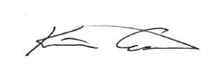

Karina Assiter, CCSC President

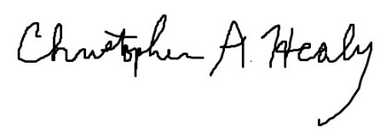

Christopher A. Healy, CCSC Vice-President & Conference Coordinator

**Hold Harmless Clause for In-Cooperation Conferences   
between the Association for Computing Machinery, Inc**.

***(hereafter known as "ACM"***) and,

Name of Conference: CCSC-EA

Dates of Conference: October 21-22, 2022

Location of Conference: DeSales University

***hereafter known as the "Conference", and***

Sponsoring Organization: _ Consortium for Computing Sciences in Colleges__________

Address: 5110 Rockhill Rd, Kansas City, MO 64110

***hereafter known as the "Sponsor(s)."***

The Sponsor(s) assumes entire responsibility for the legal and financial liabilities associated with the above named Conference.

The Sponsor(s) agree to hold harmless and indemnify ACM, its directors, officers, employees, agents, and assigns from and against any and all liability, loss, requests for payment, damages to persons and property including loss of use thereof as well as fines and penalties imposed by any governmental or regulatory authority and reasonable attorneys fees and disbursements in connection with the above captioned event.

In addition, the Sponsor(s) acknowledges that ACM does not maintain insurance covering the Sponsors and it is the sole responsibility of the Sponsor(s) to obtain comprehensive General Liability and Contractual Liability insur­ance to insure losses or casualties associated with the Conference.

The Sponsor(s) also acknowledge that there is a financial risk involved with sponsoring the Conference, and that the Sponsor(s) alone shall bear the burden of financial loss to the Conference.

I certify that I am an agent for the sponsoring organization and have the authority to make legal commitments for the organization.

For Consortium for Computing Sciences in Colleges________________________

Date May 8, 2022___________________________________________________

Name of Organization: Consortium for Computing Sciences in Colleges____ ________



By

Signature _____________________________________________

Print Name __________ Karina Assiter __________________